Hoffman Elimination
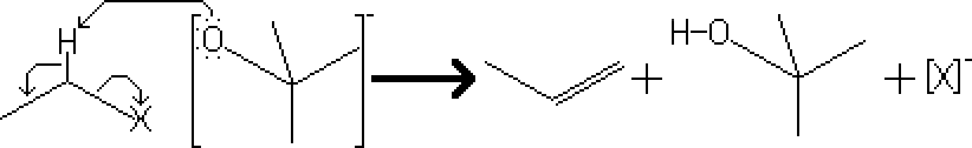
Reactants – Primary or Secondary Alkyl Halide, t-BuOK
Products – Alkene, t-BuOKH
Electron Movement
- E2 Reaction – The negatively charged oxygen removes the proton from the beta position of the alkyl halide. This causes the simultaneous formation of a double carbon-carbon bond and the dissociation of the leaving group.

Notes
- Since this reaction is based on the E2 mechanism, there are several conditions that may increase the rate of reaction
  - The product of the mechanism will lean towards the hoffman product if the base used is sterically hindered. (In our example, potassium tert-butoxide is fairly sterically hindered and will produce around 72% of hoffman product)

